**Hello World RESTful Web Service**

**HelloController.java**

package com.cognizant.springlearn.controller;

import org.slf4j.Logger;

import org.slf4j.LoggerFactory;

import org.springframework.web.bind.annotation.GetMapping;

import org.springframework.web.bind.annotation.RestController;

@RestController

public class HelloController {

    private static final Logger LOGGER = LoggerFactory.getLogger(HelloController.class);

    @GetMapping("/hello")

    public String sayHello() {

        LOGGER.info("START - sayHello()");

        String message = "Hello World!!";

        LOGGER.info("END - sayHello()");

        return message;

    }

}

**SpringLearnApplication.java**

package com.cognizant.springlearn;

import org.springframework.boot.SpringApplication;

import org.springframework.boot.autoconfigure.SpringBootApplication;

@SpringBootApplication

public class SpringLearnApplication {

    public static void main(String[] args) {

        SpringApplication.run(SpringLearnApplication.class, args);

    }

}

**application.properties**

server.port=8083

**Class**

**HelloController.class**

package com.cognizant.springlearn.controller;

import org.slf4j.Logger;

import org.slf4j.LoggerFactory;

import org.springframework.web.bind.annotation.GetMapping;

import org.springframework.web.bind.annotation.RestController;

@RestController

public class HelloController {

   private static final Logger LOGGER = LoggerFactory.getLogger(HelloController.class);

   public HelloController() {

   }

   @GetMapping({"/hello"})

   public String sayHello() {

      LOGGER.info("START - sayHello()");

      String message = "Hello World!!";

      LOGGER.info("END - sayHello()");

      return message;

   }

}

**SpringLearnApplication.class**

package com.cognizant;

import org.springframework.boot.autoconfigure.SpringBootApplication;

@SpringBootApplication

public class SpringLearnApplication {

   public SpringLearnApplication() {

      throw new Error("Unresolved compilation problem: \n\tThe declared package \"com.cognizant.springlearn\" does not match the expected package \"com.cognizant\"\n");

   }

   public static void main(String[] args) {

      throw new Error("Unresolved compilation problem: \n");

   }

}

**pom.properties**

artifactId=spring-learn

groupId=com.cognizant

version=0.0.1-SNAPSHOT

**pom.xml**

<project xmlns="http://maven.apache.org/POM/4.0.0"

         xmlns:xsi="http://www.w3.org/2001/XMLSchema-instance"

         xsi:schemaLocation="http://maven.apache.org/POM/4.0.0 http://maven.apache.org/xsd/maven-4.0.0.xsd">

    <modelVersion>4.0.0</modelVersion>

    <groupId>com.cognizant</groupId>

    <artifactId>spring-learn</artifactId>

    <version>0.0.1-SNAPSHOT</version>

    <packaging>jar</packaging>

    <name>spring-learn</name>

    <description>Spring Boot Hello World REST</description>

    <parent>

        <groupId>org.springframework.boot</groupId>

        <artifactId>spring-boot-starter-parent</artifactId>

        <version>2.7.12</version>

    </parent>

    <dependencies>

        <dependency>

            <groupId>org.springframework.boot</groupId>

            <artifactId>spring-boot-starter-web</artifactId>

        </dependency>

    </dependencies>

    <build>

        <plugins>

            <plugin>

                <groupId>org.springframework.boot</groupId>

                <artifactId>spring-boot-maven-plugin</artifactId>

            </plugin>

        </plugins>

    </build>

</project>

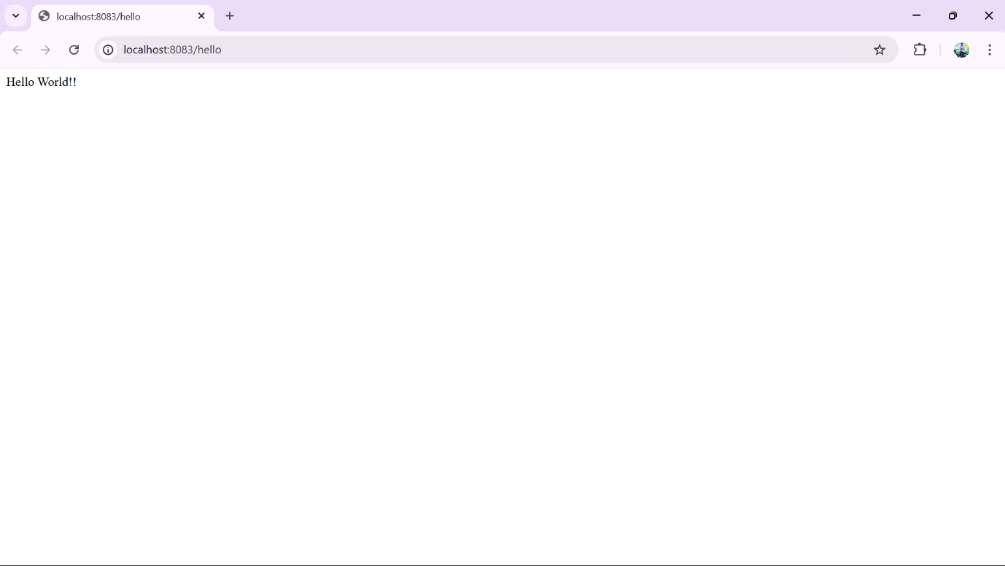**OUTPUT :**

**REST - Country Web Service   
CountryController.java**

package com.cognizant.spring_learn.controller;

import com.cognizant.spring_learn.model.Country;

import org.springframework.context.ApplicationContext;

import org.springframework.context.support.ClassPathXmlApplicationContext;

import org.springframework.web.bind.annotation.RequestMapping;

import org.springframework.web.bind.annotation.RestController;

@RestController

public class CountryController {

    @RequestMapping("/country")

    public Country getCountryIndia() {

        ApplicationContext context = new ClassPathXmlApplicationContext("country.xml");

        Country country = (Country) context.getBean("in");

        return country;

    }

}

**SpringLearnApplication.java**

package com.cognizant.spring_learn;

import org.springframework.boot.SpringApplication;

import org.springframework.boot.autoconfigure.SpringBootApplication;

@SpringBootApplication

public class SpringLearnApplication {

    public static void main(String[] args) {

        SpringApplication.run(SpringLearnApplication.class, args);

    }

}

**pom.properties**

artifactId=spring-learn

groupId=com.cognizant

version=1.0-SNAPSHOT

**pom.xml**

<project xmlns="http://maven.apache.org/POM/4.0.0"

         xmlns:xsi="http://www.w3.org/2001/XMLSchema-instance"

         xsi:schemaLocation="http://maven.apache.org/POM/4.0.0 http://maven.apache.org/xsd/maven-4.0.0.xsd">

    <modelVersion>4.0.0</modelVersion>

    <groupId>com.cognizant</groupId>

    <artifactId>spring-learn</artifactId>

    <version>1.0-SNAPSHOT</version>

    <packaging>jar</packaging>

    <name>spring-learn</name>

    <description>Spring Learn REST Country Service</description>

    <parent>

        <groupId>org.springframework.boot</groupId>

        <artifactId>spring-boot-starter-parent</artifactId>

        <version>2.7.18</version>

        <relativePath/>

    </parent>

    <properties>

        <java.version>1.8</java.version>

    </properties>

    <dependencies>

        <dependency>

            <groupId>org.springframework.boot</groupId>

            <artifactId>spring-boot-starter-web</artifactId>

        </dependency>

    </dependencies>

    <build>

        <plugins>

            <plugin>

                <groupId>org.springframework.boot</groupId>

                <artifactId>spring-boot-maven-plugin</artifactId>

            </plugin>

        </plugins>

    </build>

</project>

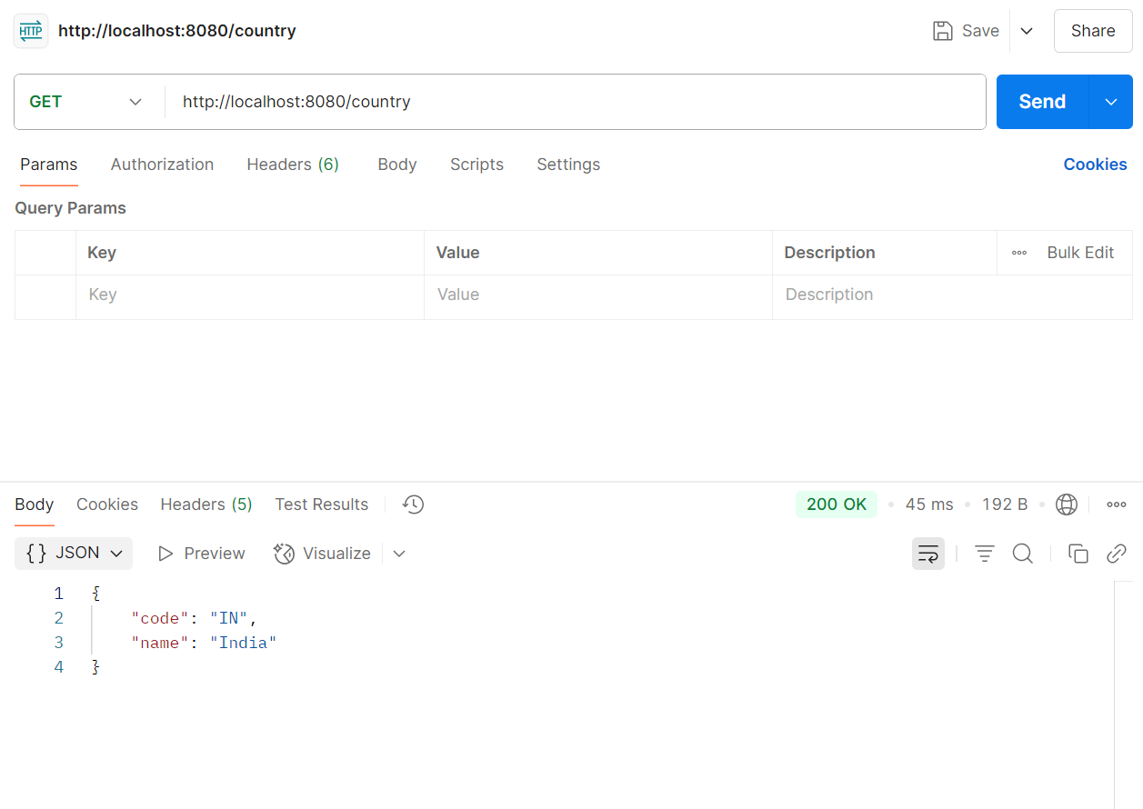**OUTPUT :**

**REST - Get country based on country code   
CountryController.java**

package com.cognizant.spring_learn.controller;

import com.cognizant.spring_learn.model.Country;

import com.cognizant.spring_learn.service.CountryService;

import com.cognizant.spring_learn.service.CountryNotFoundException;

import org.springframework.beans.factory.annotation.Autowired;

import org.springframework.web.bind.annotation.*;

@RestController

public class CountryController {

    @Autowired

    private CountryService countryService;

    @RequestMapping("/country")

    public Country getCountryIndia() {

        return new Country("IN", "India");

    }

    @GetMapping("/countries/{code}")

    public Country getCountry(@PathVariable String code) throws CountryNotFoundException {

        return countryService.getCountry(code);

    }

}

**Country.java**

package com.cognizant.spring_learn.model;

public class Country {

    private String code;

    private String name;

    public Country() {}

    public Country(String code, String name) {

        this.code = code;

        this.name = name;

    }

    public String getCode() {

        return code;

    }

    public void setCode(String code) {

        this.code = code;

    }

    public String getName() {

        return name;

    }

    public void setName(String name) {

        this.name = name;

    }

}

**SpringLearnApplication.java**

package com.cognizant.spring_learn;

import org.springframework.boot.SpringApplication;

import org.springframework.boot.autoconfigure.SpringBootApplication;

@SpringBootApplication

public class SpringLearnApplication {

    public static void main(String[] args) {

        SpringApplication.run(SpringLearnApplication.class, args);

    }

}

**Country.xml**

<?xml version="1.0" encoding="UTF-8"?>

<beans xmlns="http://www.springframework.org/schema/beans"

       xmlns:xsi="http://www.w3.org/2001/XMLSchema-instance"

       xsi:schemaLocation="http://www.springframework.org/schema/beans

       http://www.springframework.org/schema/beans/spring-beans.xsd">

    <bean id="in" class="com.cognizant.spring_learn.model.Country">

        <property name="code" value="IN"/>

        <property name="name" value="India"/>

    </bean>

</beans>

**pom.properties**

artifactId=spring-learn

groupId=com.cognizant

version=1.0-SNAPSHOT

**pom.xml**

<project xmlns="http://maven.apache.org/POM/4.0.0"

         xmlns:xsi="http://www.w3.org/2001/XMLSchema-instance"

         xsi:schemaLocation="http://maven.apache.org/POM/4.0.0 http://maven.apache.org/xsd/maven-4.0.0.xsd">

    <modelVersion>4.0.0</modelVersion>

    <groupId>com.cognizant</groupId>

    <artifactId>spring-learn</artifactId>

    <version>1.0-SNAPSHOT</version>

    <packaging>jar</packaging>

    <name>spring-learn</name>

    <description>Spring Learn REST Country Service</description>

    <parent>

        <groupId>org.springframework.boot</groupId>

        <artifactId>spring-boot-starter-parent</artifactId>

        <version>2.7.18</version>

        <relativePath/>

    </parent>

    <properties>

        <java.version>1.8</java.version>

    </properties>

    <dependencies>

        <dependency>

            <groupId>org.springframework.boot</groupId>

            <artifactId>spring-boot-starter-web</artifactId>

        </dependency>

    </dependencies>

    <build>

        <plugins>

            <plugin>

                <groupId>org.springframework.boot</groupId>

                <artifactId>spring-boot-maven-plugin</artifactId>

            </plugin>

        </plugins>

    </build>

</project>

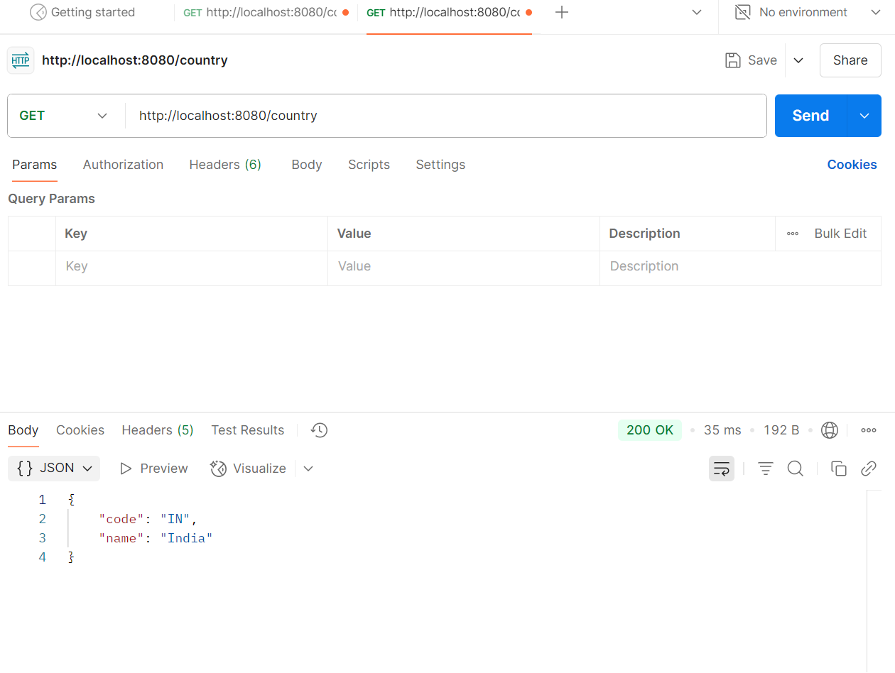**OUTPUT :**